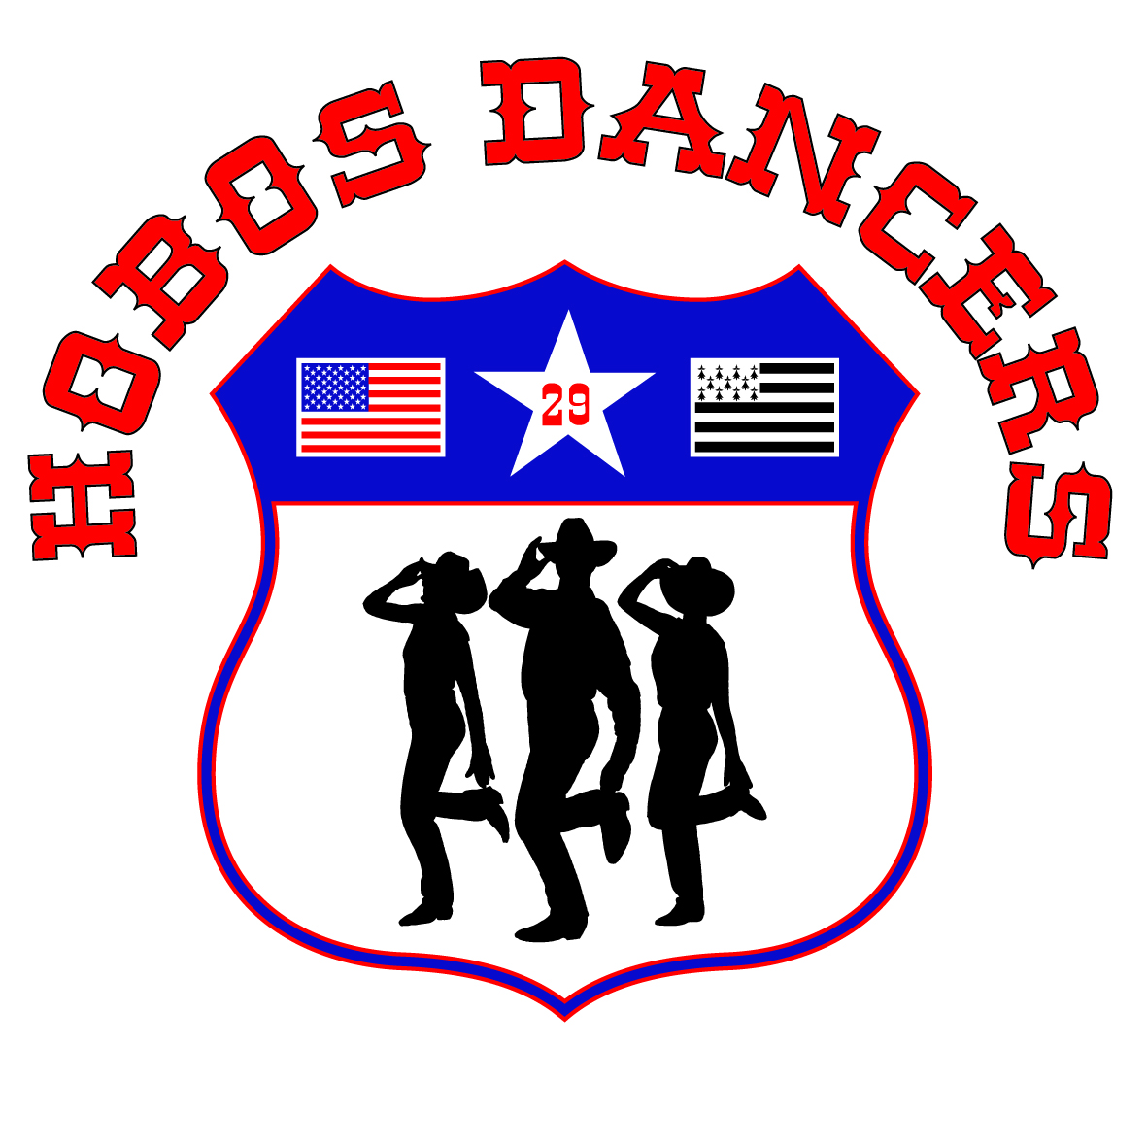
BAL DU 17 JANVIER
MEDLEY | TUSH PUSH FOR 2 | STEALING THE BEST / POT OF GOLD
FRIDAY NIGHT | LOVER PLEASE COME BACK | THE BOAT TO LIVERPOOL
SOMETHING IN THE AIR | WESTERN BARN DANCE | EARTHBOUND
HURRY UP SLOW DOWN | JUST A LITTLE LOVE | LITTLE WAGON WHEEL ROCK/ WAGON WHEEL ROCK/LOST IN ME
WE ARE TONIGHT | SHOW YOU OFF | SHE GETS ME
V - 8 | LUNAM | WHISKEY’S GONE
STOP CRYING | SHAKIN MIX | THE FINAL TEST
MUNTSA | COUNTRY RHONE VALEY | LONG TIME GONE
MONA LISA | HOT IN HERE | SLAP AND STOMP
LOUISIANA STRUT | MY EVERYTHING | BLOWN AWAY
MY DEAR JULIET | CANIBAL STOMP | WHERE THE WIND BLOWS
KING OF APOLOGY | I WANT YOUR LOVE | BABY BELLE/ THE BELLE OF LIVERPOOL
AN ABSOLUTE DREAM | FUN PUSH | LIFE IS BETTER
ROLL IN THE HAY | SUNBEAM | COUNTRY ROAD
SOMEWHERE IN MY CAR | RAGGLE TAGGLE GYSPSY O | DROWING
A ONE WAY TICKET / LIPS SO CLOSE | LETI | P 3
LOOCK OUT | CARTERS ROCK | BUILDING BRIDGES
CELTIC TEARDROPS | SILVER LINING | 1929
DRIVEN | SUNNY DAY | BRUISES
WE WERE US | HEY BROTHER | TELEPATHY
A LA DEMANDE | A LA DEMANDE | A LA DEMANDE

DEBUTANTS NOVICES INTERMEDIAIRES COUPLES

